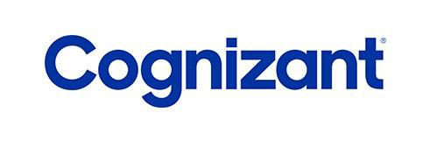
Cognizant Technology Solutions India Private Ltd.
Techno Complex, 5/535 Old Mahabalipuram Road,
Okkiyam Thoraipakkam, Chennai – 600 097.
Phone: 4209 6000
Fax: 4209 6060
TO WHOM IT MAY CONCERN
Sub: Employment Information as per our records

Employee Name : Sunil Balyan
Employee Id : 415145
Designation : Programmer Analyst
Date of Joining : February 21, 2014
Last Working Date : June 30, 2016
Employment Type : Full time (40 hours per week) Role Description :
Programmer Analyst Trainee (February 21, 2014 to February 20. 2015)

Conducted thorough analysis of new business requirements, ensuring that technical solutions aligned with business goals and customer needs.

Coded extensively using various programming languages, including C#, Java, PL-SQL, and Transact SQL, to deliver robust application functionalities.

Designed and developed UI/UX components for both web and desktop applications using modern technologies such as AngularJS and Node.js, creating user-friendly and efficient interfaces.

Conducted proof of concepts (POCs) on emerging technologies to assess their feasibility and potential for improving existing systems and processes.

Worked with business process tools such as Pega BPM and Appian BPM, contributing to the automation and optimization of business workflows.

Collaborated closely with business associates to analyze new features and provide accurate estimations for development, ensuring alignment with project timelines.

Monitored software performance on both new and existing programs, identifying issues, isolating areas for improvement, and performing necessary debugging to enhance system efficiency and stability.

Prepared key designing and development artifacts, including low-level design documents and application development estimation documents, to facilitate clear communication and project planning.

Programmer Analyst (February 21, 2015 to June 30, 2016)

- Developed software solutions tailored to client needs, continuously adapting to meet new regulations and standards in a dynamic environment.
- Designed and developed service-oriented applications using the WCF/WPF framework, ensuring seamless integration and robust performance.
- Created UI/UX components for both web and desktop applications using technologies like AngularJS, Node.js, jQuery, and Backbone.js, delivering user-friendly, interactive interfaces.
- Integrated various applications with upstream and downstream systems, ensuring smooth data exchange and improved system interoperability.
- Took end-to-end ownership of coding and development for both web and desktop applications, ensuring high-quality, scalable solutions.
- Conducted requirements gathering sessions with clients and translated their needs into design artifacts, ensuring alignment with business objectives and technical specifications.
- Worked extensively with database technologies such as Oracle and MS SQL Server, designing and optimizing schemas and stored procedures to facilitate efficient data interaction.
- Developed stored procedures to streamline data manipulation and improve application performance.
- Designed and developed facts and dimension tables, schema models, hybrid data models, ER diagrams, transformations, and materialized views to support data warehousing needs.
- Actively participated in scrum ceremonies, including daily stand-ups and retrospectives, aligning development efforts with Agile practices and ensuring timely project delivery.
- Engaged in data and code migration activities, ensuring smooth transitions from lower to higher environments while maintaining system integrity.
- Reviewed functional and technical specifications to ensure clarity and feasibility, identifying and clarifying gaps in the design phase.
- Suggested improvements to software applications, focusing on performance optimization and identifying potential areas for enhancements in production code.
- Coordinated with business users and production support teams to address and resolve production bugs, ensuring minimal system downtime.
- Led knowledge transfer sessions for onsite counterparts, ensuring smooth onboarding and alignment with development processes.

Programming Languages and Tools used:
- Microsoft visual studio
- C#, Java, Angular JS, Node JS, JQuery
- Eclipse
- Oracle – 10g, 11g
- MS SQL Server
- Jira ( Agile )
- PL-SQL Programming

Thanking You, Yours Faithfully,

For Cognizant Technology Solutions India Private Ltd

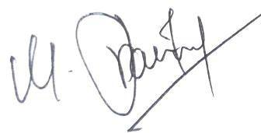
Pravin Mathiyalagan Kumar Associate Director - HR November 15, 2021

The transcribed information in this document is meant solely for visa purposes and is not intended for any other purpose.

